**COMPUTER SCIENCE PROJECT**

**“SHOPPING SITE : Clothesforyou.com”**

**Made By: Pranay Mahajan**

**Branch: CSE-OSS**

**Roll Number: 37**

**Sap ID: 500068668**

**Batch-1**

**PROJECT INTRODUCTION**

The project is about a shopping site: clothesforyou.com. The customer can login by using the username and password and buy clothes. The admin can login using his username and password. He can add and delete items. He can also search and modify items sequentially as well as randomly. Once the customer finishes the shopping he/she will be able to view the shopping cart with the total billing amount to be paid.

**CODING:**

#include<fstream.h>

#include<conio.h>

#include<stdio.h>

#include<string.h>

#include<process.h>

struct eshop

{

int category;

char name[30];

float price;

}item;

int shopcart=0;

int login()

{

char log[30];

cout<<endl;

cout<<"Enter your Login ID : ";

cin>>log;

if(strcmp(log,"ABCD") == 0)

return 1;

else

return 0;

}

int alogin()

{

char log[30];

cout<<endl;

cout<<"Enter your Login ID : ";

cin>>log;

if(strcmp(log,"abcd") == 0)

return 1;

else

return 0;

}

int pass()

{

char c[30], c1;

int check;

cout<<"Enter Password : ";

for(int i=0;;i++)

{

c1=getch();

check = c1;

if(check == 13)

{

c[i] = '\0';

break;

}

c[i] =c1;

cout<<"*";

}

if(strcmp(c,"1234") == 0)

return 1;

else

return 0;

}

int apass()

{

char c[30], c1;

int check;

cout<<"Enter Password : ";

for(int i=0;;i++)

{

c1=getch();

check = c1;

if(check == 13)

{

c[i] = '\0';

break;

}

c[i] =c1;

cout<<"*";

}

if(strcmp(c,"12345") == 0)

return 1;

else

return 0;

}

void Buyclothes()

{

char cht,chb,chj,chd,chn;

int ch, ch2,ch3,ch4,ch5,ch6;

clrscr();

cout<<"------******------It's time to shop------******------

"<<endl;

cout<<" 1.Tops "<<endl;

cout<<" 2.Bottoms "<<endl;

cout<<" 3.Jumpsuits "<<endl;

cout<<" 4.Dresses "<<endl;

cout<<" 5.Nightsuits "<<endl;

cout<<" 6.Checkout "<<endl;

cout<<" Enter Choice: ";

cin>>ch;

if(ch == 6)

{

cout<<"Your total bill is: "<<shopcart<<endl;

cout<<"Press any key... ";

getch();

}

else

{

ifstream f1;

f1.open("itemlist.dat",ios::in|ios::binary);

cout<<"S.No. \t";

cout<<"Price \t";

cout<<"Category"<<endl;

int cnt=1;

f1.seekg(0,ios::beg);

while(f1.read((char*)&item,sizeof(item)))

{

if(item.category==ch)

{

cout<<cnt<<"\t";

cout<<item.price<<"\t";

cout<<item.name<<endl;

cnt++;

}

}

f1.close();

cout<<cnt<<"\t"<<"Go back to menu"<<endl;

cnt++;

cout<<cnt<<"\t"<<"Checkout"<<endl;

cnt = cnt-2;

cout<<endl<<"Enter your choice: ";

cin>>ch2;

if(ch2==(cnt+1))

{

Buyclothes();

}

else if(ch2==(cnt+2))

{

cout<<"Your total bill is: "<<shopcart ;

cout<<endl <<endl;

cout<<"Press any key... ";

getch();

}

else

{

ifstream f2;

f2.open("itemlist.dat",ios::in|ios::binary);

f2.seekg(0,ios::beg);

cnt=0;

while(f2.read((char*)&item,sizeof(item)))

{

if(item.category==ch)

{

cnt++;

if(ch2==cnt)

{

cout<<"Are you sure you want to buy this

item(y/n): "<<endl;

cin>>cht;

if(cht=='y')

{

cout<<"Your item has been

successfully added to your

shopping cart!"<<endl;

cout<<"Press any key.. ";

getch();

shopcart=shopcart+item.price;

}

break;

}

}

}

f2.close();

Buyclothes();

}

}

}

void iwrite()

{

char rep='y';

ofstream f1;

f1.open("itemlist.dat",ios::app|ios::binary);

do

{

cout<<"-----------------------------------------------"<<endl;

cout<<" 1.Tops "<<endl;

cout<<" 2.Bottoms "<<endl;

cout<<" 3.Jumpsuits "<<endl;

cout<<" 4.Dresses "<<endl;

cout<<" 5.Nightsuits "<<endl;

cout<<"-----------------------------------------------"<<endl;

cout<<"Enter category: ";

cin>>item.category;

cout<<"Enter item name: ";

gets(item.name);

cout<<"Enter price: ";

cin>>item.price;

f1.write((char*)&item,sizeof(item));

cout<<"Item successfully added !! "<<endl<<endl;

cout<<"Do you wish to add more? (y/n) ";

cin>>rep;

}while(rep=='y');

getch();

f1.close();

}

void iread()

{

clrscr();

ifstream f1;

f1.open("itemlist.dat",ios::in|ios::binary);

f1.seekg(0,ios::beg);

cout<<"Category: \t";

cout<<"Price: \t";

cout<<"Item Name: "<<endl<<endl;

while(f1.read((char*)&item,sizeof(item)))

{

cout<<item.category<<"\t";

cout<<item.price<<"\t";

cout<<item.name<<endl;

}

getch();

f1.close();

}

void idelete()

{

clrscr();

cout<<" Deletion of item! "<<endl;

char reply='n';

ifstream f1;

ofstream f2;

f1.open("itemlist.dat",ios::in|ios::app|ios::binary);

f2.open("temp.dat",ios::in|ios::out|ios::binary);

f1.seekg(0,ios::beg);

f2.seekp(0,ios::beg);

while(f1.read((char*)&item,sizeof(item)))

{

cout<<"Category: "<<item.category<<"\t";

cout<<"Price: "<<item.price<<"\t";

cout<<"Item name: "<<item.name<<endl;

cout<<endl<<"Do you wish to delete this record? (y/n) ";

cin>>reply;

if(reply == 'n')

{

f2.write((char*)&item,sizeof(item));

}

}

f1.close();

f2.close();

remove("itemlist.dat");

rename("temp.dat","itemlist.dat");

}

void iseq_search()

{

clrscr();

cout<<" Searching item sequentially!"<<endl;

char reply = 'n';

ifstream f1;

f1.open("itemlist.dat",ios::in|ios::binary);

f1.seekg(0,ios::beg);

while(f1.read((char*)&item,sizeof(item)) && reply!='y')

{

cout<<"Category: "<<item.category<<"\t";

cout<<"Price: "<<item.price<<"\t";

cout<<"Item name: "<<item.name<<endl;

cout<<endl<<"Is this the record you were searching for?

(y/n) ";

cin>>reply;

cout<<endl;

}

if(reply == 'y')

cout<<endl<<"Record found !";

else

cout<<endl<<"Record not found !";

getch();

f1.close();

}

void rand_search(int rec_no)

{

ifstream f1;

f1.open("itemlist.dat",ios::in|ios::binary);

f1.seekg((rec_no-1)*sizeof(item));

f1.read((char*)&item,sizeof(item));

cout<<"Category: "<<item.category<<"\t";

cout<<"Price: "<<item.price<<"\t";

cout<<"Item name: "<<item.name<<endl;

cout<<endl<<"Record found!"<<endl;

getch();

f1.close();

}

void iseq_modify()

{

clrscr();

cout<<" Modifying item list sequentially! "<<endl;

char reply = 'n';

ifstream f1;

ofstream f2;

f1.open("itemlist.dat",ios::in|ios::binary);

f2.open("temp.dat",ios::out|ios::binary);

f1.seekg(0,ios::beg);

f2.seekp(0,ios::beg);

while(f1.read((char*)&item,sizeof(item)))

{

cout<<"Category: "<<item.category<<"\t";

cout<<"Price: "<<item.price<<"\t";

cout<<"Item name: "<<item.name<<endl;

cout<<endl<<"Is this the record you wish to modify?

(y/n) ";

cin>>reply;

cout<<endl;

if(reply == 'y')

{

cout<<endl<<"Enter new details: "<<endl<<endl;

cout<<"Enter category: ";

cin>>item.category;

cout<<"Enter item name: ";

gets(item.name);

cout<<"Enter price: ";

cin>>item.price;

cout<<"Record Modified!";

f2.write((char*)&item,sizeof(item));

}

else

f2.write((char*)&item,sizeof(item));

}

getch();

f1.close();

f2.close();

remove("itemlist.dat");

rename("temp.dat","itemlist.dat");

}

void rand_modify(int rec_no)

{

fstream f1;

f1.open("itemlist.dat",ios::in|ios::out|ios::binary);

f1.seekg(0,ios::beg);

f1.seekp(0,ios::beg);

f1.seekg((rec_no-1)*sizeof(item));

f1.read((char*)&item,sizeof(item));

cout<<endl<<"This is the record to be modified: ";

cout<<endl<<endl;

cout<<"Category: "<<item.category<<endl;

cout<<"Item name: "<<item.name<<endl;

cout<<"Price: "<<item.price<<endl;

cout<<endl<<"Enter new details: "<<endl<<endl;

cout<<"Enter category: ";

cin>>item.category;

cout<<"Enter item name: ";

gets(item.name);

cout<<"Enter price: ";

cin>>item.price;

f1.seekp((rec_no-1)*sizeof(item));

f1.write((char*)&item,sizeof(item));

f1.close();

cout<<" Record Modified! ";

getch();

}

void admin_menu()

{

clrscr();

int choice;

cout<<"=====================*ADMIN MENU*

===================="<<endl;

cout<<" 1. Add items"<<endl;

cout<<" 2. Delete items"<<endl;

cout<<" 3. Search items(sequentially)"<<endl;

cout<<" 4. Search items(randomly)"<<endl;

cout<<" 5. Modify items(sequentially)"<<endl;

cout<<" 6. Modify items(randomly)"<<endl;

cout<<" 7. Display items "<<endl;

cout<<" 8. Exit "<<endl;

cout<<"=====================================

================"<<endl;

cout<<"Enter choice: ";

cin>>choice;

if(choice==8)

{

cout<<"Exiting... ";

getch();

exit(0);

}

else if(choice==7)

{

iread();

getch();

}

else if(choice==1)

{

iwrite();

iread();

}

else if(choice==2)

{

idelete();

}

else if(choice == 3)

{

iseq_search();

}

else if(choice == 4)

{

clrscr();

cout<<" Searching item randomly!";

int rec_no;

cout<<"Enter the record to be searched: ";

cin>>rec_no;

rand_search(rec_no);

}

else if(choice == 5)

{

iseq_modify();

}

else if(choice == 6)

{

clrscr();

cout<<" Modifying item list randomly! ";

int rec_no;

cout<<endl<<"Enter the record no. to be modified: ";

cin>>rec_no;

rand_modify(rec_no);

}

admin_menu();

}

void main()

{

clrscr();

int ch,ch1,choice;

int check,check1;

cout<<"------*****------MAIN MENU------*****------";

cout<<endl;

cout<<" 1. Customer Login "<<endl;

cout<<" 2. Admin Login "<<endl;

cout<<"-------------------------------------------"<<endl<<endl;

cout<<"Enter choice: ";

cin>>ch;

if(ch==1)

{

clrscr();

check=login();

check1=pass();

if(check==1&&check1==1)

{

cout<<endl<<endl<<"Login Successful!!!";

cout<<endl<<"Press any key... ";

getch();

clrscr();

cout<<endl<<endl;

cout<<"------******------Welcome to

Clothesforyou.com------******------";

cout<<endl;

cout<<" 1. Buy Clothes " <<endl;

cout<<" 2. Logout "<<endl;

cout<<"Enter choice: ";

cin>>ch1;

if(ch1==1)

{

Buyclothes();

getch();

}

if(ch1==2)

{

cout<<"Logging Out... ";

getch();

exit(0);

}

}

else

{

cout<<endl<<endl;

cout<<"Incorrect Login ID or Password !! ";

cout<<endl<<"Press any key... ";

getch();

}

}

if(ch==2)

{

clrscr();

check=alogin();

check1=apass();

if(check==1&&check1==1)

{

cout<<endl<<endl<<"Login Successful!!!";

cout<<endl<<"Press any key... ";

getch();

admin_menu();

}

else

{

cout<<endl<<endl;

cout<<"Incorrect Login ID or Password !! ";

cout<<endl<<"Press any key... ";

getch();

}

}

}

**OUTPUTS:**

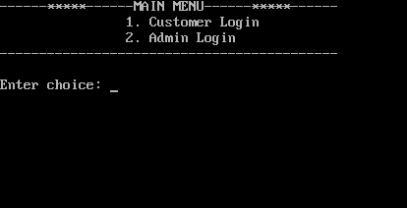

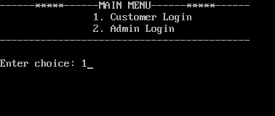

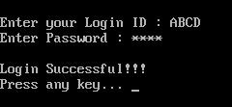 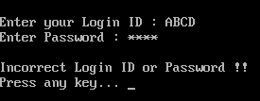

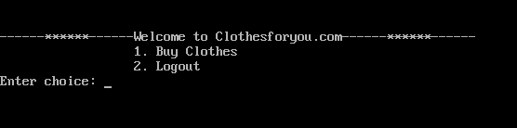

**CUSTOMER LOGIN:**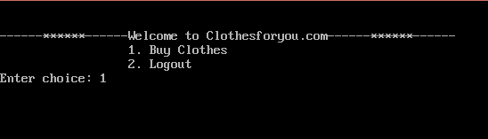

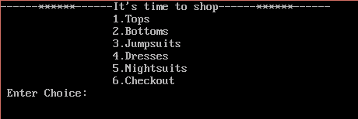

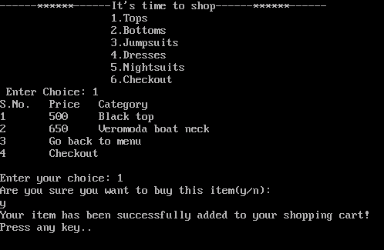

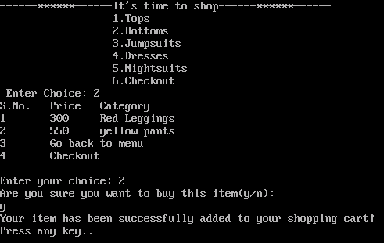

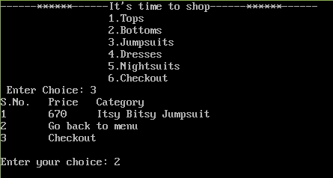

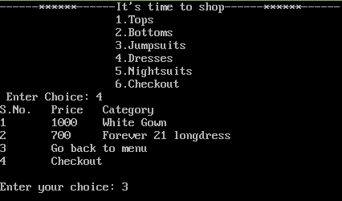

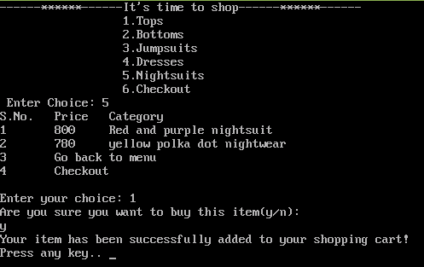

**SHOPPING CART:**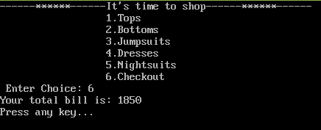

**LOGOUT:**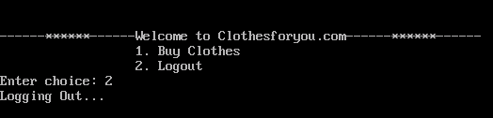

**ADMIN LOGIN:**

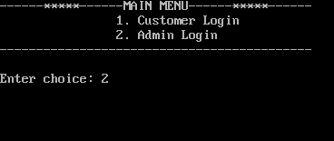

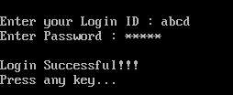 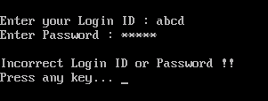

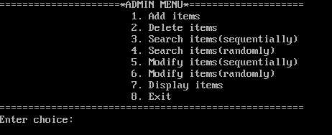

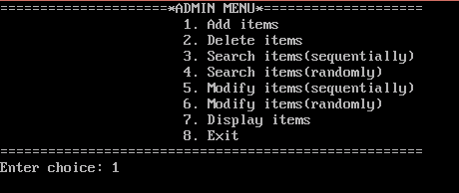

**ADDITION OF ITEMS:**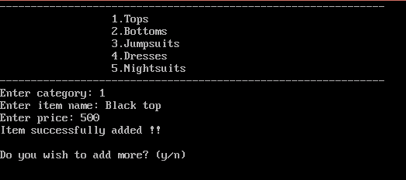

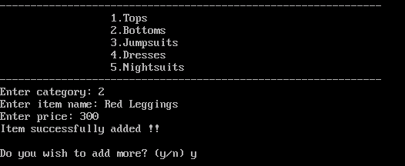

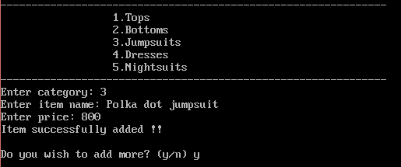

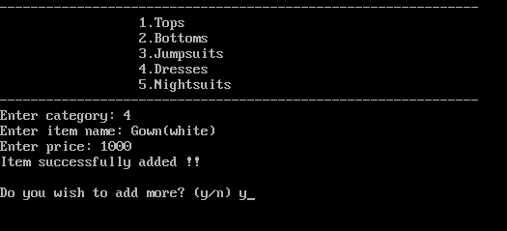

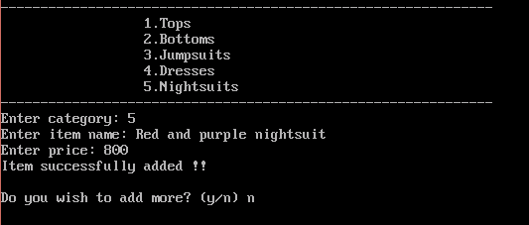

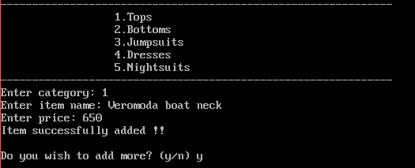



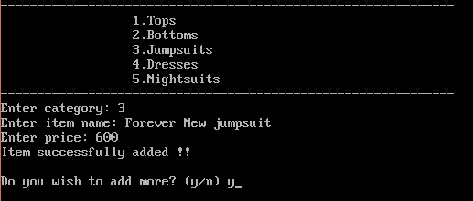



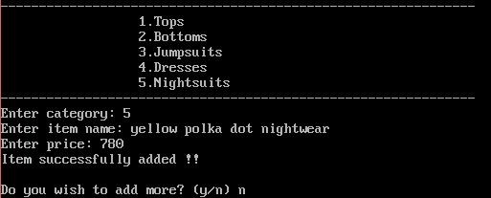

**DISPLAY AFTER ADDITION:**

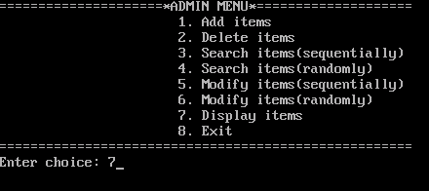

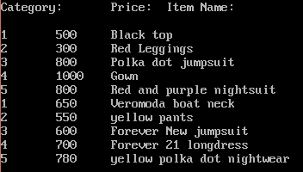

**DELETION OF ITEM:**

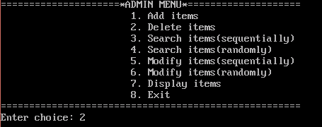

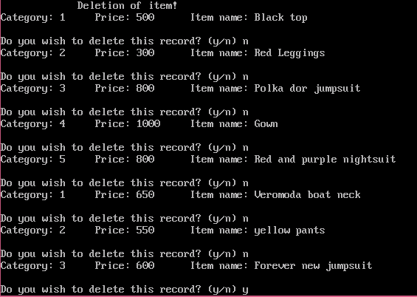

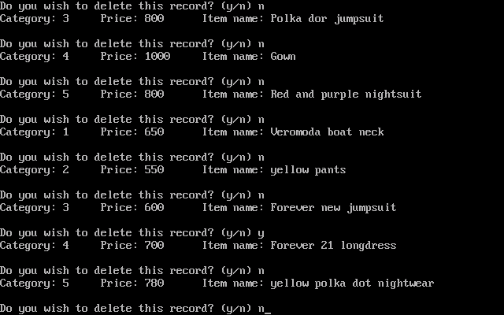

**DISPLAYING AFTER DELETION:**

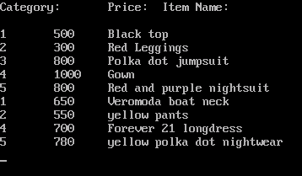

**SEARCHING ITEM SEQUENTIALLY:**

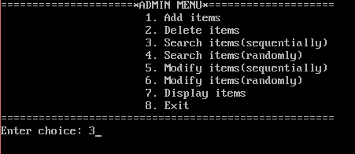

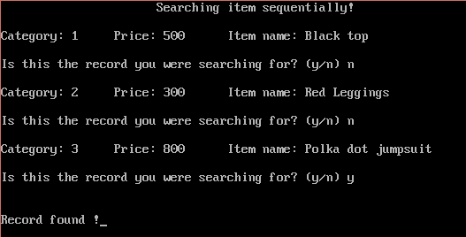

**SEARCHING ITEM RANDOMLY:**

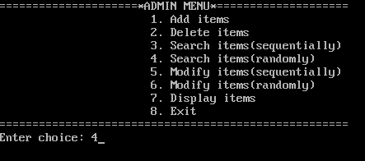

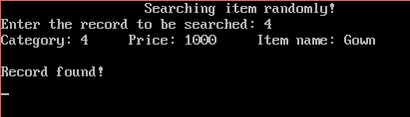

**MODIFYING ITEM LIST SEQUENTIALLY:**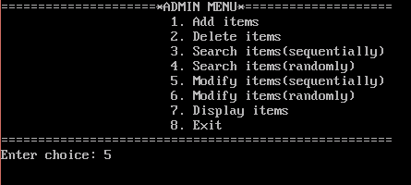

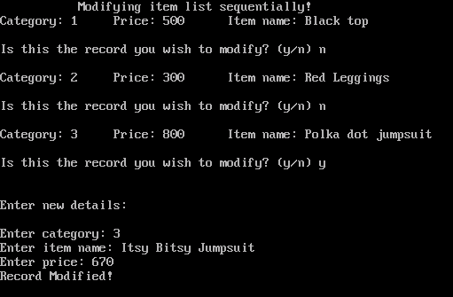

**MODIFYING ITEM LIST RANDOMLY:**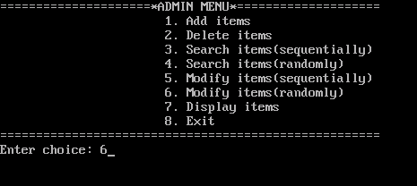

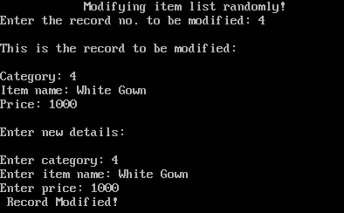

**DISPLAY AFTER MODIFYING:** 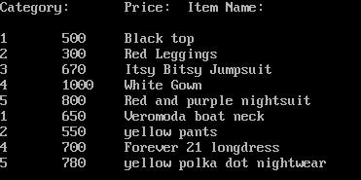

**EXITING:**

